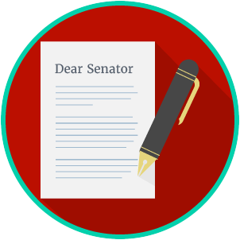
Engaged Citizens: SS.7.C.2.10
Influencing the Government
READING GUIDE #2
Name: _______________________

Date: ________________________
Reading: Methods of the Media

Benchmark Clarification 2: Students will identify the methods used by the media to monitor and/or influence the government.

Reading Task | Response
What ideas are presented in the reading?
What is the central idea of the reading?
Select two words or phrases that support the central idea.
How might this reading connect to your own experience or something you have seen, read, or learned before?
How can the media monitor or influence government? | The media can monitor or influence government by:

