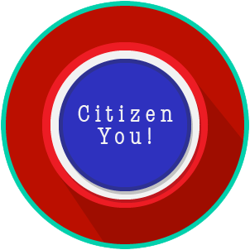
Citizen You: SS.7.C.2.2, C.2.3 & C.2.14
Citizen Obligations &
Responsibilities
READING GUIDE #2
Name: _______________________

Date: ________________________

Reading: Citizens and the Common Good

Benchmark Clarification 2: Students will recognize the concept of the common good as a rationale for fulfilling the obligations and/or responsibilities of citizenship.

Reading Task | Response
What ideas are presented in the reading?
What is the central idea of the reading?
Select two words or phrases that support the central idea.
How might this reading connect to your own experience or something you have seen, read, or learned before?
How does the concept of the common good relate to citizenship? | The common good relates to citizenship in that:

