High School U.S. Government Classroom  Principles of American Democracy  VIDEO VIEWING GUIDE #3 | Name: ______________  Date: _______________

Question | List Specific Evidence  from the Video | Complete Sentence
1.What is the principle of due process?

2. Where do we find due process in the U.S. Constitution?

3. What is the difference between due process in the 5th Amendment as compared to due process in the 14th Amendment?
4. View the card image.
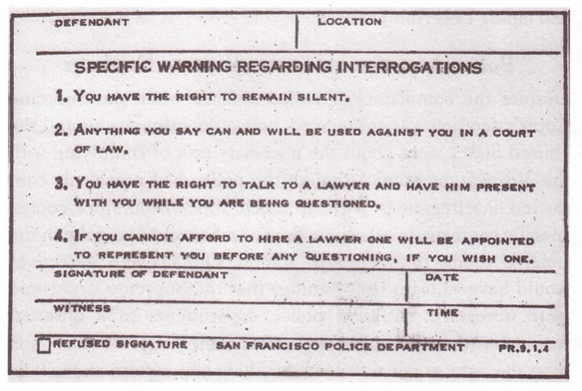
What is the card pictured above? How does it represent protection for due process?

