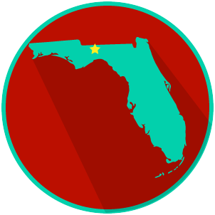
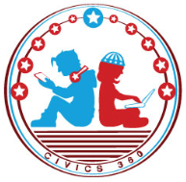
FL State & Local Government: SS.7.C.3.13
Comparing Constitutions
VIDEO VIEWING GUIDE #1
Name: ______________________________

Date: _______________________________

Comparing the U.S. and Florida Constitutions Video #1
Question | List Specific Evidence from the Video | Complete Sentence
1. What is the Supreme Law of the Land?

2. What are four things that the U.S. Constitution does?

3. What are the 3 purposes of a constitution?
4. What are three ways that the structure of U.S. Constitution and the Florida Constitution are similar?
5. What is a preamble?

6. Why do both the U.S. Constitution and the Florida Constitution begin with ‘We the People’?
7. What is an article?
8. What is an amendment?
9. Where will we find the rights of Florida citizens in the Florida Constitution?
10. What is the Supremacy Clause?

FL State & Local Government: SS.7.C.3.13
Comparing Constitutions
VIDEO VIEWING GUIDE #2
Name: ______________________________

Date: _______________________________

The Amendment Process Video #2
Question | List Specific Evidence from the Video | Complete Sentence
1. What does it mean to ‘amend’ a constitution?

2. What are the two ways an amendment can be proposed for the U.S. Constitution?

3. What are the two ways an amendment to the U.S. Constitution can be ratified?
4. Based on what you have learned, who is involved in the U.S. Constitution’s amendment process?
5. Who must agree to amend the Florida Constitution?

6. Why do both the U.S. Constitution and the Florida Constitution begin with ‘We the People’?
7. Explain the five different ways an amendment gets on the ballot in Florida.
7a. Constitutional Revision Commission
7b. Taxation and Budget Reform Commission
7c. Constitutional Convention
7d. Ballot Initiative Process
7e. The Florida Legislature
8. How are amendments to Florida’s constitution ratified?

FL State & Local Government:
SS.7.C.3.13
Comparing Constitutions
READING GUIDE #1
Name: ______________________

Date: _______________________
Reading: Purposes of a Constitution

Benchmark Clarification 1: Students will identify the purposes of a constitution (provides a framework for government, limits government authority, protects the rights of the people).

Reading Task | Response
What ideas are presented in the reading?
What is the central idea of the reading?
Select two words or phrases that support the central idea.
How might this reading connect to your own experience or something you have seen, read, or learned before?
What is the purpose of a constitution? | The purpose of a constitution is to:

FL State & Local Government:
SS.7.C.3.13
Comparing Constitutions
READING GUIDE #2
Name: ______________________

Date: _______________________

Reading: Structure of the U.S. and Florida Constitutions

Benchmark Clarification 2: Students will recognize the basic outline of the U.S. and Florida constitutions (both have articles, amendments, and preambles).

Reading Task | Response
What ideas are presented in the reading? (use other side if necessary)
What is the central idea of the reading?
Select two words or phrases that support the central idea.
How might this reading connect to your own experience or something you have seen, read, or learned before?
Describe three ways the U.S. and Florida Constitutions are the same, and three ways they are different. | Similarities  1.
 | 2.
 | 3.
Differences
1.
 | 2.
 | 3.
FL State & Local Government:
SS.7.C.3.13
Comparing Constitutions
READING GUIDE #3
Name: ______________________

Date: _______________________

Reading: Comparing Amendment Processes

Benchmark Clarification 3: Students will compare the amendment process of the U.S. and Florida constitutions.

Reading Task | Response
What ideas are presented in the reading?
What is the central idea of the reading?
Select two words or phrases that support the central idea.
How might this reading connect to your own experience or something you have seen, read, or learned before?
Which constitution is probably more difficult to amend, the Florida or U.S., and why? | The most difficult constitution to amend is probably the __________________________________________ because:

FL State & Local Government:
SS.7.C.3.13
Comparing Constitutions
READING GUIDE #4
Name: ______________________

Date: _______________________

Reading: Supreme Law of the Land

Benchmark Clarification 4: Students will compare the amendment process of the U.S. and Florida constitutions.

Reading Task | Response
What ideas are presented in the reading?
What is the central idea of the reading?
Select two words or phrases that support the central idea.
How might this reading connect to your own experience or something you have seen, read, or learned before?
What do we mean when we say the U.S. Constitution is the supreme law of the land? | When we say the U.S. Constitution is the supreme law of the land, we mean that:

FL State & Local Government: SS.7.C.3.13
Comparing Constitutions
VOCABULARY PRACTICE
Name: ______________________

Date: _______________________
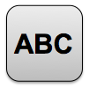

Comparing Constitutions

Write about your understanding of the purpose of a constitution by explaining the connections between and among each of the terms in the concept circle.

How do the terms in the concept circle fit together?

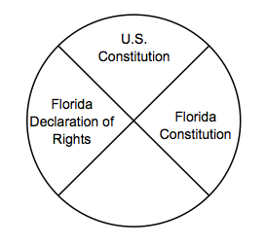

FL State & Local Government SS.7.C.3.13
Comparing Constitutions
PRACTICE QUIZ
Name: _______________________

Date: ________________________
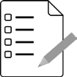
Comparing Constitutions Practice Quiz Reflection

FIRST Attempt Score | I answered ______ questions right.
One thing I learned:

SECOND Attempt Score | I answered ______ questions right.
One thing I learned:

